NOT FOR PUBLICATION WITHOUT THE
APPROVAL OF THE APPELLATE DIVISION

SUPERIOR COURT OF NEW JERSEY
APPELLATE DIVISION
DOCKET NO. A-0944-07T1

DARRELL HATCHER,

Plaintiff-Respondent,

v.

BOUCHRA HADIDDOU,

Defendant-Appellant.

___________________________________
February 1, 2008
Argued December 18, 2007 - Decided

Before Judges Fuentes and Chambers.

On appeal from Superior Court of New Jersey, Chancery Division, Family Part, Essex County, FM-07-1416-07.

Jessica N. Weinstein argued the cause for appellant (Law Offices of Weinstein & Weinstein, attorneys; Ms. Weinstein, of counsel and on the brief).

Bette R. Grayson argued the cause for respondent (Grayson & Associates, L.L.C., attorneys; Ms. Grayson, of counsel; Elena K. Weitz, on the brief).

PER CURIAM

By leave granted, we are required to consider whether New Jersey has jurisdiction over this family dispute. Although the family had originally lived in New Jersey and the father still lives in this State, since the children have resided outside this State for more than six months preceding the custody application, we now hold that this State does not have jurisdiction under the New Jersey Uniform Child Custody Jurisdiction and Enforcement Act (NJUCCJEA). N.J.S.A. 2A:34-53 to -95. Accordingly, the order of October 5, 2007, asserting jurisdiction over this dispute, providing for parenting time, and scheduling a hearing on custody, parenting time and child support, is reversed.
Plaintiff Darrell Hatcher and defendant Bouchra Hadiddou were married on October 28, 2002, in New Jersey, and thereafter had two children together. In December 2005, defendant left the State with the two children and did not return. The parties dispute the circumstances under which defendant left the State with the children. Plaintiff maintains that he gave defendant permission to take the children on a trip to Morocco for a family visit, and that she never returned to New Jersey. Plaintiff states that for the next two years, despite his efforts to locate defendant and the children, including two trips to Morocco, he did not know where they were. Defendant disputes this contention, maintaining that the parties had separated in December 2005, and that she had advised plaintiff that she was living in Florida, where she maintains she has resided with the children for the last two years.
On January 5, 2007, plaintiff filed a pro se complaint in New Jersey seeking a divorce based on desertion. While the complaint recites that two children were born of the marriage, no specific relief was sought regarding custody, visitation or child support. Due to plaintiff's inability to locate defendant, an order was entered on May 11, 2007, pursuant to Rule 4:4-5(c), allowing defendant to be served by publication. The required notice was published in The Star Ledger on June 8, 2007. A default judgment of divorce was entered July 24, 2007, dissolving the marriage but providing no other relief.
Defendant filed a Notice of Motion in the New Jersey Superior Court on August 14, 2007, seeking an order vacating the default judgment of divorce and permission to proceed with the divorce litigation in Florida. In the alternative, she sought leave to file an answer and counterclaim in New Jersey, an award of sole custody of the children, and an order for child support. Although no New Jersey order had been entered on custody, the motion papers indicate that she was making a special appearance to contest New Jersey's jurisdiction on any custody determination.
Plaintiff filed opposition and a cross-motion seeking joint legal custody of the children and parenting time with the children and requesting that any child support order consider the lower cost of living in Florida.
On the day the motions were heard, defendant withdrew her request to vacate the default judgment of divorce. The trial judge found that New Jersey had jurisdiction over the alimony, custody, and child support issues, and provided plaintiff with parenting time for the children. His order of October 5, 2007, directed defendant to return the children to New Jersey within twenty days, and a hearing was scheduled for November 8, 2007, on the issues of alimony, custody and child support. This interlocutory appeal followed.
We note that defendant did not provide the trial court with the legal authority presented to this court in support of her position. However, since defendant raised the issue before the trial court and the matter goes to jurisdiction, this court will entertain the argument. See Nieder v. Royal Indem. Ins. Co., 62 N.J. 229, 234 (1973) (stating that appellate courts decline to consider issues not raised below unless they relate to jurisdiction or involve matters of "great public interest"); Pressler, Current N.J. Court Rules, comment 2 on R. 2:6-2 (2008) (noting that so long as an issue was raised below, a different theory may be advanced on appeal).
Defendant contends that under the provisions of the NJUCCJEA, New Jersey does not have jurisdiction of the custody dispute in this case. We agree for the following reasons.
The NJUCCJEA is modeled after the Uniform Child Custody Jurisdiction and Enforcement Act (UCCJEA) promulgated by the National Conference of Commissioners on Uniform State Laws in 1997. Senate Judiciary Committee Statement to S. 150 (May 13, 2004) (reprinted following N.J.S.A. 2A:34-53). We note that Florida has also enacted a similar law. Fla. Stat. §§ 61.501- 61.542 (2007).
The NJUCCJEA provides rules for determining which state has jurisdiction in "child custody determinations." N.J.S.A. 2A:34-53 to -95. The statutory definition of "child custody determination" includes legal and physical custody issues and visitation issues, but does not include support disputes. N.J.S.A. 2A:34-54. The NJUCCJEA provides that the "initial determination" for child custody must be brought in the state where the child is residing or where the child has resided within the six months preceding the commencement of the action. N.J.S.A. 2A:34-65(a). The NJUCCJEA defines "initial determination" as "the first child custody determination concerning a particular child." N.J.S.A. 2A:34-54. Here, the New Jersey divorce action did not commence the "initial determination," because no request for child custody was included in that action. The issue of child custody was raised in New Jersey for the first time in the motions made in the summer of 2007, which was more than six months after the children had left the State. Accordingly, New Jersey does not have jurisdiction of the child custody issue.
Plaintiff argues that defendant should not be able to defeat the jurisdiction of New Jersey by "kidnapping" the children from the father and taking them out of State. We note that once this State has taken proper jurisdiction under N.J.S.A. 2A:34-65, the provisions in the NJUCCJEA providing for continuing jurisdiction of the court effectively prevent a parent from thereafter defeating the jurisdiction of this State by wrongfully removing the children. See N.J.S.A. 2A:34-66(a). Further, under the provisions of the NJUCCJEA, another court does not have jurisdiction to modify the determination of the court which had initial jurisdiction except under the specific circumstances provided in the NJUCCJEA. N.J.S.A. 2A:34-67. However, none of these provisions help plaintiff here; New Jersey cannot make the initial determination at this juncture because the children did not reside here within six months of the application, as required by N.J.S.A. 2A:34-65.
We do note that if defendant did engage in "unjustifiable conduct," the Florida courts have the discretion to decline jurisdiction under the UCCJEA. N.J.S.A. 2A:34-72; Fla. Stat. § 61.521 (2007). In that event, New Jersey may be able to obtain jurisdiction under N.J.S.A. 2A:34-65(a)(2).
However, at this time, for all of these reasons, New Jersey does not have jurisdiction over the custody and parenting time issues regarding the children of this marriage.
Reversed.
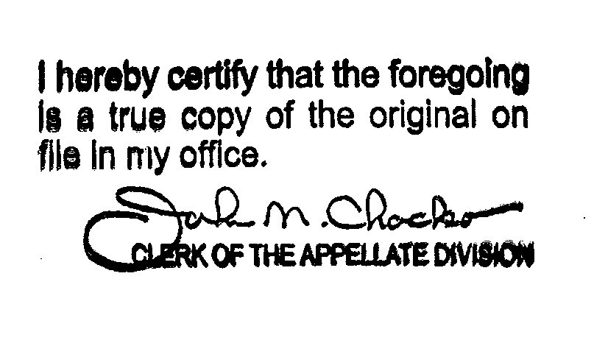

In light of the fact that defendant did not want to vacate the New Jersey judgment of divorce and her position that Florida, not New Jersey, has jurisdiction over the custody and child support issues, we are at a loss to understand why she brought an application in New Jersey in the first place, which then required litigation of this jurisdictional issue.

