NOT FOR PUBLICATION WITHOUT THE
APPROVAL OF THE APPELLATE DIVISION

SUPERIOR COURT OF NEW JERSEY
APPELLATE DIVISION
DOCKET NO. A-1592-06T5

DEBORAH BRIGGS,

Plaintiff-Respondent,

v.

THOMAS LUISI, MOHAMMED
KENDIL, E&D STUCCO, SEVEN
ACRES TRUST CO., RICHARD
BELLON, E.I.F.S. OF N.J., INC.,
BUILDING DIAGNOSTICS, INC., and
H&J FREILE HOME INSPECTION, INC.,

Defendants,

and

ADAM GROSZ,

Defendant-Appellant.
_____________________________________________________________
August 31, 2007

Submitted July 17, 2007 - Decided

Before Judges Fuentes and Graves.

On appeal from Superior Court of New Jersey,
Law Division, Hunterdon County, Docket No.
L-269-04.

Hilberth & McAlvanah, attorneys for
appellant Adam Grosz (Thomas R. Hilberth,
on the brief).

Hoagland, Longo, Moran, Dunst & Doukas,
attorneys for respondent (Joan Howell
Osborne, of counsel and on the brief).

PER CURIAM

Defendant Adam Grosz appeals from a portion of an order entering judgment in favor of plaintiff Deborah Briggs in the amount of $89,485.16. The judgment was based on a jury verdict, which apportioned twenty percent of the total damages to defendant and found he violated the Consumer Fraud Act (CFA), N.J.S.A. 56:8-1 to -166. Thus, the judgment entered against defendant on October 3, 2006, included treble damages in the amount of $67,114.20 and counsel fees in the amount of $22,370.96. The balance of the judgment, in the amount of $285,170.68, was entered against Thomas Luisi, who defaulted.
On appeal, defendant presents the following arguments:
POINT I

DEFENDANT DID NOT VIOLATE THE CONSUMER FRAUD ACT IN ISSUING A WARRANTY, BREACH OF WARRANTY IS NOT A PER SE VIOLATION OF THE ACT, AND DEFENDANT WAS GIVEN NO OPPORTUNITY TO PERFORM.

POINT II

IT WAS ERROR FOR THE COURT NOT PERMITTING TESTIMONY ON THE SALES PRICE OF THE PROPERTY SHOWING A SUBSTANTIAL GAIN, WHEN PLAINTIFF STATED SHE PURCHASED THE PROPERTY AS AN INVESTMENT.

POINT III

THE VERDICT FORM CONFUSED THE JURY.

POINT IV

THE VERDICT VIOLATES THE SPIRIT AND PURPOSE OF THE CONSUMER FRAUD ACT AND IS UNJUST AND AGAINST THE WEIGHT OF THE EVIDENCE.

After considering these contentions in light of the record and the applicable law, we conclude there was ample evidence to support the jury verdict, there was no prejudicial error warranting a new trial, and defendant's arguments are without sufficient merit to warrant discussion in a written opinion. R. 2:11-3(e)(1)(E). We therefore affirm.
Plaintiff was residing in Michigan when she contracted to purchase a home in Hunterdon County and arranged various property inspections through the realtor––John Bendall. Although the property was held in the name of Seven Acre Trust, Luisi was identified as the seller of the property. As a result of the inspections, certain deficiencies were discovered in the home's Exterior Insulation and Finished System (EIFS).
According to plaintiff and Bendall, when the seller was advised of the inspection deficiencies, he agreed to make the necessary repairs, and Bendall testified the seller hired defendant to do the work:
Q. Was it your understanding that the seller agreed to take care of the stucco issue?

A. Oh, yes.

Q. At his own expense?

A. Yes.

Q. All right. And in order to take care of those issues, did the seller retain the services of anyone to perform the remedial work to the stucco?

A. Yes.

Q. All right. And do you know who that person was?

A. Yes.

Q. And who was that person?

A. It was the gentleman over here.

Q. Right here?

A. Yes, sir.

Q. Adam Grosz, right here.

A. Adam Grosz, yeah.

The inspection reports identified a number of problems that needed to be corrected, but the major problem, according to plaintiff's testimony, was "the surface of the home" and related issues:
[T]he most apparent area of problems was on the back porch and there were some very large cracks from the corner of the window sill down to the deck surface of the porch on the outside. There were some cracks around the foundation of the home where they had applied the surface and it was either falling off and/or cracked. They pointed out that it was critical with this type of product that silicone caulking had to be maintained on a regular basis around the windows to prevent moisture from going behind and then creating a sponge-like effect of water penetration. And so recommended that there be some additional caulking be put around some of the windows where the caulking wasn't as much as they felt it needed to be.

Plaintiff testified she was unwilling to purchase the home unless the seller made the necessary repairs and a warranty was provided "to validate that the overall home, the surface of the home was in good condition." After the inspection reports were sent to Luisi, he obtained a proposal from defendant, a stucco contractor, to do the necessary repair work. In his proposal, defendant stated he would repair the house foundation, the "back wall," the deck foundation, and the pool house wall; and he would caulk all windows and install four-inch molding for the total sum of $7,980. In addition, defendant's proposal stated he would guarantee his work against defects and cracks for five years. According to plaintiff, Luisi agreed to have all of the necessary repair work completed by defendant prior to closing of title. At the closing on July 22, 1999, Luisi provided plaintiff with a five-year warranty signed by defendant, which guaranteed the "exterior stucco surface and stucco foundation against defects and cracks for five years."
Grosz acknowledged he signed the five-year warranty Luisi prepared, but he testified Luisi informed him plaintiff's bank only wanted "the bend in the back porch" fixed. Thus, according to defendant, that was the only repair Luisi authorized, and it was the only repair work he performed. However, the warranty Luisi prepared, and defendant signed, reads as follows:
Dear Ms. Briggs,

This letter serves as documentation of the EIFS warranty for you and Princeton Mortgage Company. Adam Grosz Sto Contracting Services guarantees the 2 Carkhuff Road, Flemington, New Jersey property exterior stucco surface and stucco foundation against defects and cracks for five years.

Adam Grosz

Defendant also testified as follows:
Q. Mr. Grosz, the $850 that you told Tom Luisi you would charge him to do that limited amount of work, that's not reflected anywhere in your proposal, is it?

A. No.

Q. Where did that number come from?

A. He asked me how much was this job to do because nobody wants to pay for the big job, so he told me to do the small area (indiscernible) opening in the porch.

Q. Right. And one last thing, just to be clear to the jury. When you signed what's been marked as P-10 for identification, this warranty, this letterhead wasn't on there, but all the writing down here, that was on there and you read that before you signed it, right?

A. Yes.

Liability under the CFA can be premised on three general categories of unlawful acts: affirmative acts, knowing omissions, and regulatory violations. Thiedemann v. Mercedes-Benz USA, 183 N.J. 234, 245 (2005); Cox v. Sears Roebuck & Co., 138 N.J. 2, 17 (1994). Affirmative acts include unconscionable commercial practices, fraud, deception, false promise or pretense, and misrepresentation. Ibid. Neither an intent to deceive nor knowledge of the falsity of the representation is an element of a cause of action based on affirmative acts. Gennari v. Weichert Co. Realtors, 148 N.J. 582, 605 (1997). Rather, liability is established by showing the defendant's actions merely constituted a prohibited practice. Thiedemann, supra, 183 N.J. at 245; Cox, supra, 138 N.J. at 17-18; Scibek v. Longette, 339 N.J. Super. 72, 78 (App. Div. 2001); Ji v. Palmer, 333 N.J. Super. 451, 461-62 (App. Div. 2000). The standard of proof is preponderance of the evidence. Liberty Mut. Ins. Co. v. Land, 186 N.J. 163, 175-77 (2006); Gennari v. Weichert Co. Realtors, 288 N.J. Super. 504, 541 (App. Div. 1996), aff’d as modified, 148 N.J. 582 (1997).
In this case, defendant acknowledged he gave an EIFS warranty to plaintiff for work that he never did, knowing plaintiff and the lending institution (plaintiff's bank) would rely on the warranty. Moreover, plaintiff testified if defendant "had done the work and fixed [the EIFS] and/or he had refused to sign the warranty that warrantied the entire home, [she] would not have gone through this hell because [she] wouldn't have purchased the house." Thus, it was not unreasonable for the jury to conclude defendant violated the CFA.
The verdict of a jury should not be set aside unless, having given due regard to the opportunity of the jury to pass upon the credibility of the witnesses, it clearly appears there was a miscarriage of justice under the law. R. 4:49-1(a); Baxter v. Fairmont Food Co., 74 N.J. 588, 599 (1977); Dolson v. Anastasia, 55 N.J. 2, 6-7 (1969); Law v. Newark Bd. of Educ., 175 N.J. Super. 26, 37 (App. Div. 1980); see also R. 2:10-1. In this case, the record fully supports the jury's verdict, and we are convinced defendant received a fair trial.
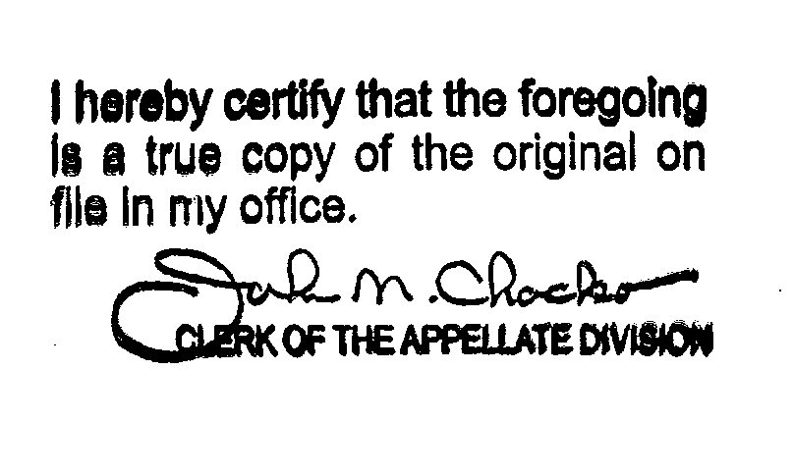
Affirmed.

We refer to Adam Grosz as defendant because the other named defendants either settled prior to trial or defaulted.
Prior to the commencement of trial, the judge informed the jury that the case was "about allegations of consumer fraud, negligence and breach of contract in connection with the application of something called a[n] [E]xterior [I]nsulation and [F]inishing [S]ystem, otherwise known as a type of synthetic stucco on the outside of plaintiff's house."

